GCSE to A-Level Mathematics Transition Work
Thomas Mills High School
https://www.mymaths.co.uk/
School Username: mills
Password: alternate
We would like every student who begins the A Level Maths course in September to be as fully prepared as possible. With this in mind, you should be doing some revision between now and joining us in September.
All students should complete the transition section on MyMaths. This can be accessed by selecting the A-level curriculum, Pure and then “Bridging from GCSE”.
To find this, go onto the website using the details provided above. Once you have logged in, navigate on the left-hand side to the A-Level Section and complete all of the “bridging from GCSE” topics in Pure, Statistics and Mechanics. Use the Lesson to help understand and the online homework’s to check your understanding.
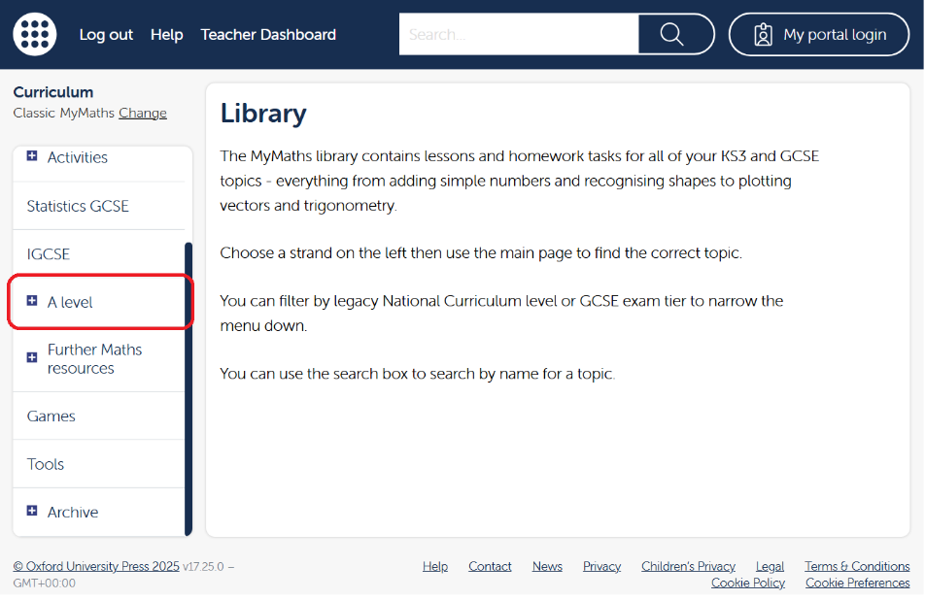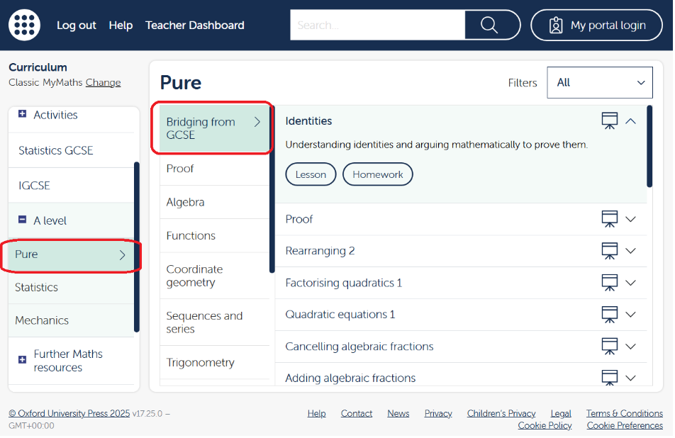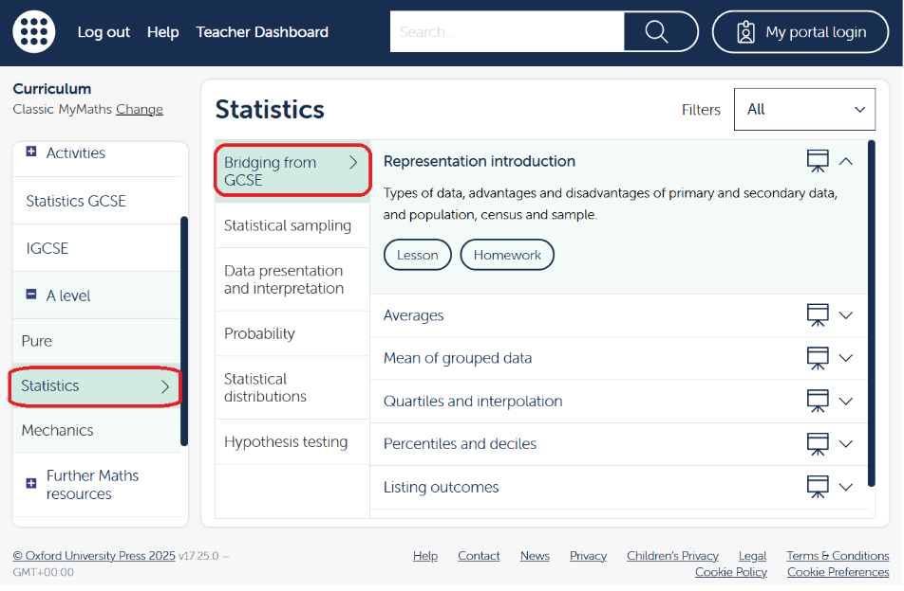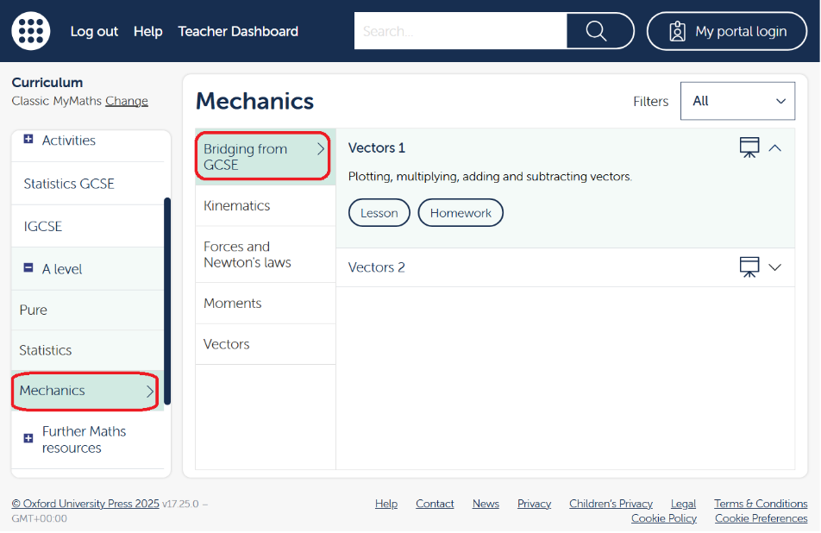
You should also complete the following tasks in Number – Powers and Roots – Indices 1-4 and Surds 1-2.
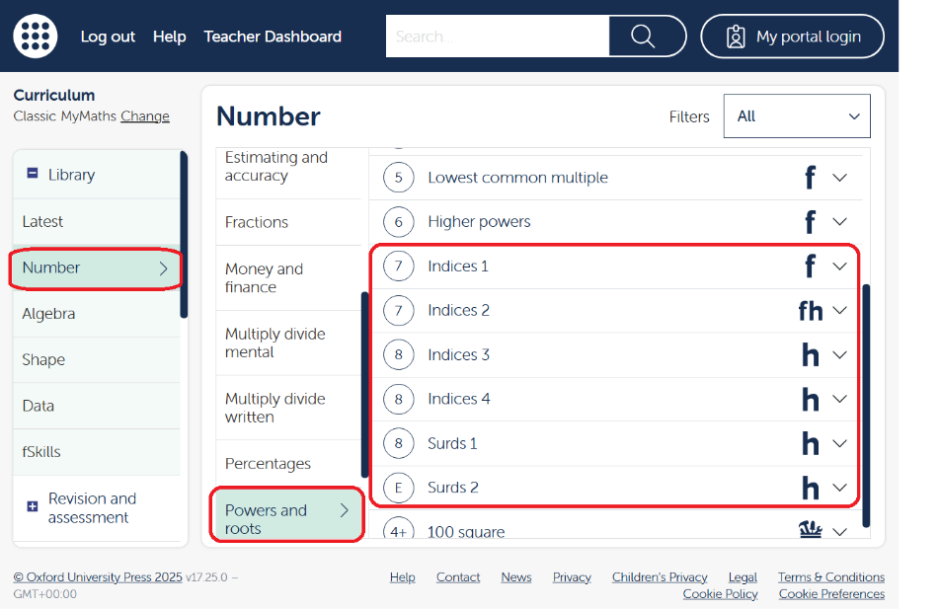
Once you have completed these tasks you should ensure that you understand all of the questions on the following pages, for model solutions please email severett@thomasmills.suffolk.sch.uk or jbayle@thomasmills.suffolk.sch.uk.
We will carry out a short test in September containing these topics so ensure you’re prepared!

