Online Safety Newsletter

May 2025

PURP App

PURP is a social networking app rated as 12+ on the App store. PURP state that it is a ‘meet and chat’ platform, allowing users to swipe right to send a friend request. If they accept, then you can chat with each other. As users are connecting with strangers, we would not recommend this app being used by teens/children. There are clearly potential safeguarding concerns, such as inappropriate contact or content.

This article from the NSPCC provides further information about chat apps , plus outlines the risks of chat rooms: https://www.nspcc.org.uk/keeping-children-safe/online-safety/social-media/chat-apps/

Cyberbullying

What is cyberbullying?
Cyberbullying is a form of bullying that takes place online and can take many forms, such as sending malicious messages. Cyberbullying can happen at any time of the day, so often feels unrelenting. It can take place across many different platforms, such as on messaging apps like WhatsApp and Snapchat, on social media platforms such as Instagram and TikTok and via online games. Here are some examples of what cyberbullying can look like online:

- Sending nasty or hurtful messages
- Leaving unkind comments
- Sharing photographs of somebody else without their permission
- Excluding somebody on purpose
- Impersonating somebody with a fake account
- Telling/sharing lies
- Blackmailing

What should I do if my child is being bullied online?

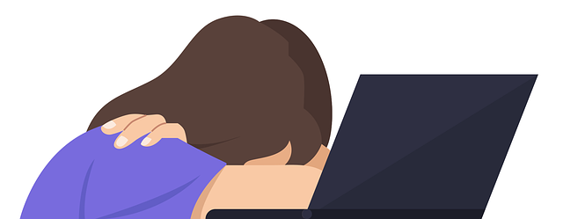
If your child is being bullied, then try to stay calm and let them know that it is not their fault. It is always useful to keep evidence of any online bullying and inform their school so that they are aware. Show your child how to block and/or report any users/content and review their privacy settings to limit what others can see. You may also wish to review/set up any available parental controls.
JusTalk

Users can use this app to video chat, call, and text. There are two versions – JusTalk and JusTalk Kids with both versions having the option to unlock further functions via a premium subscription. JusTalk is rated as 12+ and JusTalk Kids is rated as 4+ on the App store.

Even though the apps may be rated as age appropriate for your child, there are still risks in using either version.

The Ineqe Safeguarding Group provide an overview of JusTalk, including the risks you need to be aware of:
https://ineqe.com/2023/02/08/what-is-the-justalk-app/

Further information
There is a vast amount of information available online about cyberbullying. The following links provide further information on types of online bullying, and who you can contact if you need any further advice or support.
- https://www.childnet.com/help-and-advice/online-bullying/
- https://anti-bullyingalliance.org.uk/tools-information/advice-and-support/advice-parents-and-carers/sources-information-advice-and

Users of this guide do so at their own discretion. No liability is entered into. Current as of the date released 01.05.25. The inclusion of any links does not imply any affiliation with or endorsement of the linked websites, documents, or videos, nor are we claiming any ownership or copyright in the content of the linked materials.
Discord

Discord is a social networking app originally designed for gamers but is now used by lots of different people to chat to each other online. The minimum age to access Discord is 13. The App store rates it as 17+.

Discord is made up of servers, which are spaces for groups to chat, upload files and share images etc. Anybody can set up a server and they can either be public or private. Users can video call and send direct messages to other individuals or groups. Children who play online games such as Fortnite may use Discord to chat whilst playing the game (rather than using the game’s own chat facility). In-app purchases are available through Discord’s subscription service called Nitro.

How can I make it safer?
Discord have created a Family Centre, which provides further information about what Discord is, as well as information about different safety settings that can be applied:
https://discord.com/safety-family-center

As always, we would encourage you to chat to your child to see why they use different apps/websites and ensure that they know how to block users and what to do if they see any inappropriate content. It is important to be aware that Discord does include video/voice calling which cannot be filtered. Discord is used by an array of users and therefore adult content can be found on Discord as well as inappropriate language. Discord have produced this article, which answers frequent questions:
https://discord.com/safety/360044149591-answering-parents-and-educators-top-questions

Further information
https://www.internetmatters.org/advice/apps-and-platforms/social-media/discord/

New parental controls
Roblox

What is Roblox?
Roblox is a platform consisting of a collection of games. Players can either create games or play games that other users have created. It is free to download (however subscription options and in game/app purchases are available) and can be played across numerous devices.

A lot of the content is user generated, which may mean not all games will be suitable for your child to view/play. If your child is playing Roblox, it is important to monitor what your child is accessing and set up appropriate parental controls.

PEGI rate Roblox with a Parental Guidance label, this is because it is difficult to rate due to the huge level of user generated content.

New Parental Features
Roblox have released three new parental controls for your child’s Roblox account. These are:

- Friend blocking - you can now block anyone on your child’s friends list that you do not want them direct messaging.
- Experience blocking – you can now block any specific experiences (games) that you do not want your child to access.
- Top game insights - you can now see the 20 experiences (games) your child has spent the most time on in the last week.

You can find out more here: https://corp.roblox.com/newsroom/2025/04/new-parental-controls-on-roblox

Further information
You can find out more about Roblox here: https://en.help.roblox.com/hc/en-us/articles/30428248050068-Parental-Controls-FAQ
Ask Silver Scam Checker

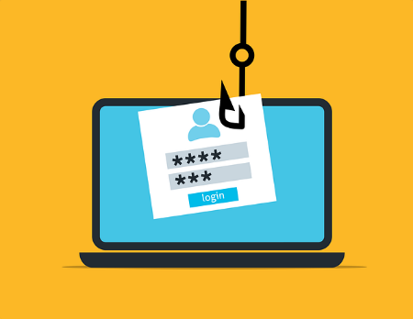
Ask Silver is a tool that anyone with a smartphone can use to protect themselves from scams. To use the service, you will first need to sign up and then you can simply upload a screenshot of anything that you are unsure of, and think could be a scam. Ask Silver will let you know whether they think it is safe or not. Find out more here:
https://www.getsafeonline.org/asksilver/

